Pilot Line Production of Transceiver Modules for Next the Generation of Smart RF Power Application
Start Date  Duration  Project number  Topic addressed | : 2019 September 1st  : 36 months  : 869817  : H2020-EIC-FTI-2018-2020  (Fast Track to the Innovation)

Work Package X : Title of Work Package
DX.X – Title of deliverable
Due date | T₀+X
Submission date | T₀+X
Lead contractor | Entity
Dissemination Level | CO or PU

Partner’s organization approval
 | Name | Function | Date | Signature
Prepared by:
Approved by:

Distribution list
Quantity | Organization |  | Names
1 | Thales Research and Technology | TRT | Afshin ZIAEI
2 | CIDETE Ingenieros SL | CIDETE | German NORIEGA
3 | RF Microtech SRL | RFM | Hamza EL GHANNUDI
4 | Foundation for Research & Technology - Hellas | FORTH | George KONSTANTINIDIS
5 | TAIPRO Engineering | TAIPRO | Bruno HEUSDENS

Chance Record Sheet
Partner number | Date | Page number | Description
Template | 22/09/2019
Version 0 | 25/09/2019

List of tables
Table 1 : Example of table 7

List of figures
Figure 1 : Example of figure 8

CONTENTS
Partner’s organization approval 3
Distribution list 3
Chance Record Sheet 4
List of tables 5
List of figures 5
CONTENTS 6
Main Title 7
1. Title 1 7
1.1 Subtitle 1 7
1.1.1 Subtitle 2 7

Main Title

Title 1

Subtitle 1

Subtitle 2

Text hefuiehrczencvznevhn

xxx | xxx | xxxx | xxx
Table 1 : Example of table

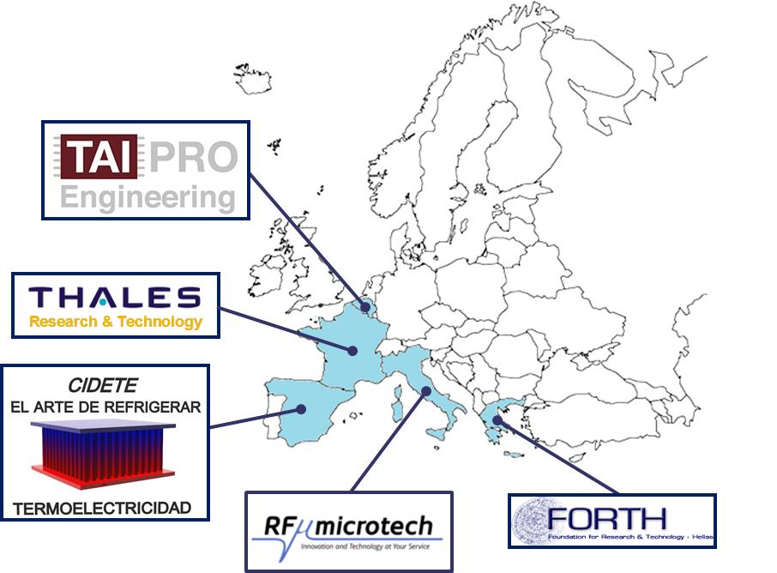
Figure 1 : Example of figure

