Pilot Line Production of Transceiver Modules for Next the Generation of Smart RF Power Application
Start Date  Duration  Project number  Topic addressed | : 2019 September 1st  : 36 months  : 869817  : H2020-EIC-FTI-2018-2020 (Fast Track to the Innovation)

Minutes of Progress Meeting #1
Date :
Location :

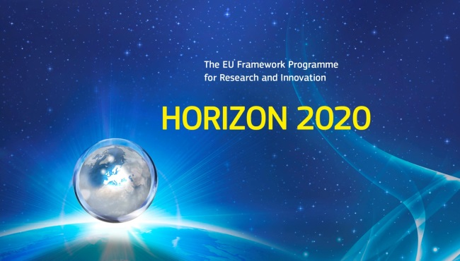 | 

Partner’s organization approval
 | Name | Function | Date | Signature
Prepared by:
Approved by:

Distribution list
Partner number | Organization |  | Names
1 | Thales Research and Technology | TRT | - Afshin ZIAEI  - Matthieu LE BAILLIF  - Paolo MARTINS  - Laurent DIVAY
2 | CIDETE Ingenieros SL | CIDETE | - German NORIEGA  - Dieter PLATZEK  - Alexandra NORIEGA  - Carlos NORIEGA  - Almudena MARQUINA
3 | RF Microtech SRL | RFM | - Hamza EL GHANNUDI  - Paolo FARINELLI
4 | Foundation for Research & Technology - Hellas | FORTH | - George KONSTANTINIDIS  - Loukas MICHALAS  - Athanasios KOSTOPOULOS  - Antonios STAVRINIDIS  - George STAVRINIDIS
5 | TAIPRO Engineering | TAIPRO | - Bruno HEUSDENS  - Michel SAINT-MARD

Chance Record Sheet
Partner number | Date | Page number | Description
Template | 22/09/2019
Version 1 | 21/02/2020 | 11
…
…
Version N

CONTENTS
Partner’s organization approval 3
Distribution list 3
Chance Record Sheet 4
CONTENTS 5
1. List of Participants 6
2. Agenda of Progress Meeting #1 7
3. Summary of presentations and discussions 9

List of Participants

Date : | January 21st & 22^{sd}, 2020
Location : | LIEGE  TAIPRO Engineering  WLS Labs Building  15 rue Bois Saint Jean (The Labs)  B-4102 Seraing  BELGIUM
Contacts : | Project Coordinator  Afshin ZIAEI  Ph: +33 169 415 777 / Mob: +33 6 8924 8810  Email :afshin.ziaei@thalesgroup.com
TAIPRO contact
Bruno HEUSDENS
Ph: +32 (0)4 353 30 12
Email: b.heusdens@taipro.be

Partner number | Organization |  | Names
1 | Thales Research and Technology | TRT | - Afshin ZIAEI  - Matthieu LE BAILLIF  - Paolo MARTINS
2 | CIDETE Ingenieros SL | CIDETE | - German NORIEGA  - Dieter PLATZEK  - Alexandra NORIEGA
3 | RF Microtech SRL | RFM | - Hamza EL GHANNUDI  - Paolo FARINELLI
4 | Foundation for Research & Technology - Hellas | FORTH | - George KONSTANTINIDIS  - Loukas MICHALAS
5 | TAIPRO Engineering | TAIPRO | - Bruno HEUSDENS  - Michel SAINT-MARD

Example of Agenda for the Progress Meeting #1
Tuesday 21th January 2020
09h00 | Opening, Welcome and Agenda
09h30 – 10h00 | Introduction: general presentation and organizational aspects | TRT
10h00 – 10h30 | Presentation of WP1 - Project management  - Objectives & means  - Schedule of main milestones & deliverables  - Inputs / Outputs over the project duration  - Summary of work : T0 – T0+5  - Focus on the perid T₀+5 – T₀+8 | TRT
10h30 | Break
11h00 – 12h30 | Presentation of WP2 - SMARTEC Pilot Line  - Objectives & means  - Schedule of main milestones & deliverables  - Inputs / Outputs over the project duration  - Summary of work : T0 – T0+5  - Focus on the period T₀+5 – T₀+8 | FORTH
12h30 – 14h00 | Lunch
14h00 – 16h00 | Presentation of WP2 - SMARTEC Pilot Line  - Objectives & means  - Schedule of main milestones & deliverables  - Inputs / Outputs over the project duration  - Summary of work : T0 – T0+5  - Focus on the period T₀+5 – T₀+8 | FORTH
16h00 – 16h15 | Break
16h15 – 17h30 | Presentation of the WP3 - Prototyping  - Objectives & means  - Schedule of main milestones & deliverables  - Inputs / Outputs over the project duration  - Summary of work : T0 – T0+5  - Focus on the period T₀+5 – T₀+8 | RFM
19h30 | Diner

Wednesday 22^{sd} January 2020
09h30 – 11h00 | Presentation of the WP4 - Marketing & Business Development  - Objectives & means  - Schedule of main milestones & deliverables  - Inputs / Outputs over the project duration  - Summary of work : T0 – T0+5  - Focus on the period T₀+5 – T₀+8 | CIDETE
11h00 – 11h30 | Presentation of the WP5 - Ethics requirements  - Objectives & means  - Schedule of main milestones & deliverables  - Inputs / Outputs over the project duration  - Summary of work : T0 – T0+5  - Focus on the period T₀+5 – T₀+8 | TRT
11h30 – 12h00 | Technical discussion / Working group
12h00 – 13h30 | Lunch
13:30 – 15h30 | Visit of TAIPRO
15h30 | End of Meeting

All the presentations made during the Progress Meetings will be available as soon as possible on the website. We report here only the contents of the discussions that occurred during the presentations.

Summary of presentations and discussions
azertyui

